**How to amend my card details if I am paying by recurring card payment?**

1. Use the following link: <https://www.payments.ed.ac.uk/customer-card-update>
2. Confirm the email address used to set up your original payment mandate (it needs to be the payer’s email address).

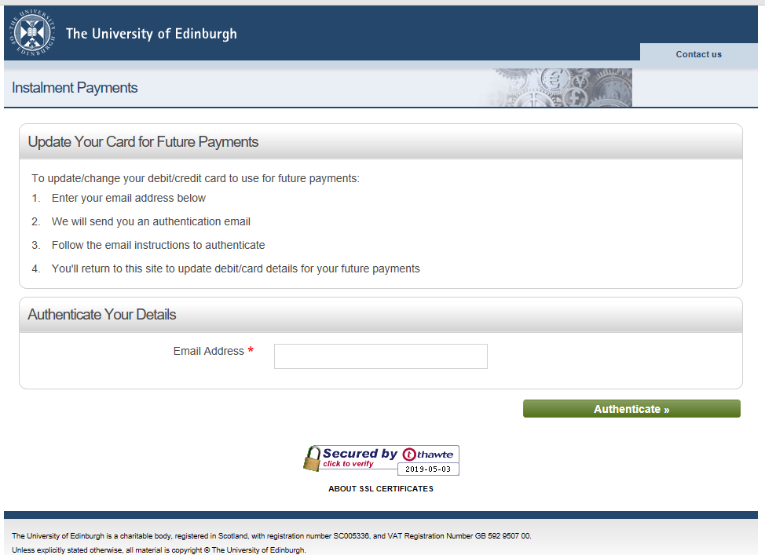

1. You will then receive instructions on how to change your card details from [finance@ed.ac.uk](mailto:finance@ed.ac.uk)

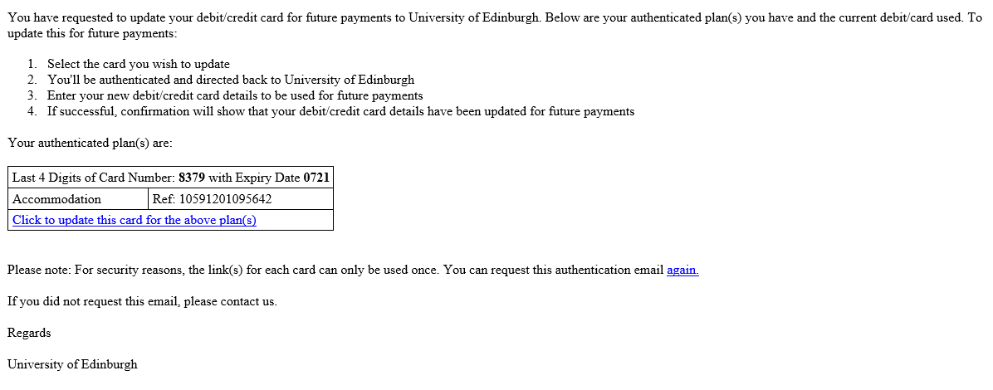

1. Click on the link provided to register your new card details.

Please note that no email confirmation will be sent once the card has been changed (we are working with our payment provider to improve on this functionality in future).